EXERCISE
- Basic Greeting Script:
- Create a script named welcome.sh that prints a simple welcome message and then on a new line, displays the output of the pwd command.
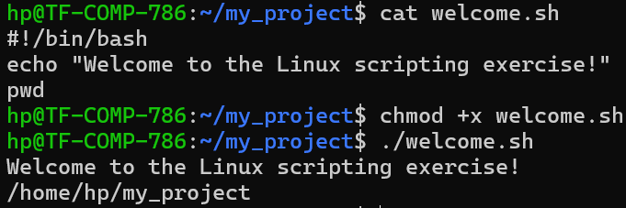
- Using Variables:
- Create a script named user_info.sh.
- Inside the script, create a variable named USERNAME and set its value to your own name.
- The script should print a message like: "The script owner is: [Your Name]".
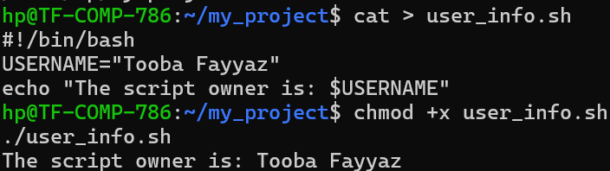
- Using Positional Parameters:
- Write a script named file_creator.sh that accepts one argument: a filename.
- The script should create an empty file with the name provided as the argument.
- The script should then print a confirmation message: "File '[filename]' has been created."
- (Hint: Use the touch command and the $1 variable).
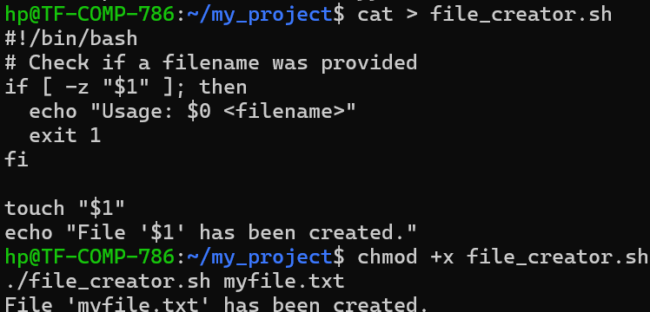
- Using Built-in Variables:
- Write a script named arg_check.sh.
- The script should print the following information:
  - "The script's name is: [script name]"
  - "You provided [number] arguments."
- (Hint: Use the $0 and $# variables).
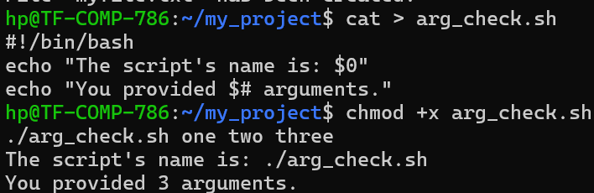
- Putting It All Together:
- Create a script named dir_report.sh that takes a directory path as its only argument.
- The script should perform the following actions: 1. Print a message: "--- Generating report for directory: [directory path] ---" 2. Create a variable that stores the number of items in that directory. (Hint: use command substitution with a pipeline like ls [directory path] | wc -l). 3. Print another message: "The directory contains [number] items."
